Menu order N _____ of ________ 20__ г. Сompleted form to be sent via e-mail: expomeal@yandex.ru

Customer:
Date and time:
Location:
Number of participants:
Name and phone:
e-mail:
Name | Amount  Data  ________ | Amount  Data  ________ | Amount  Data  ________ | Amount  Data  ________ | Amount  Data  _________ | Number of servings | Total amount | Rental price per unit in a day (ruble) | Pledge (ruble) per unit
Highball "Casa blanka" Pasabahe 280 ml  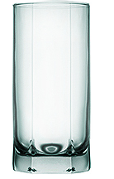 |  |  |  |  |  |  |  | 150.00 | 150.00
Wine glass "Imperrial  250 ml  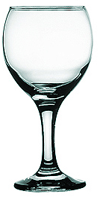 |  |  |  |  |  |  |  | 150.00 | 150.00
Wine/water glass "Imperrial  345 ml  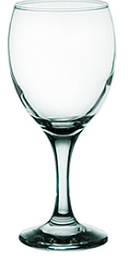 |  |  |  |  |  |  |  | 150.00 | 150.00
Champagne glass (glass flute) "Imperrial" 215 ml  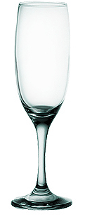 |  |  |  |  |  |  |  | 150.00 | 150.00
Ice (1 kg) |  |  |  |  |  |  |  | 400.00
Ice bucket |  |  |  |  |  |  |  | 250.00 | 1500.00
Cost of delivery of glass and ice to the stand |  |  |  |  |  |  |  | 600.00
Total for payment

